Process: Resetting a password in the Online Store
Date: January 15, 2019
Author: Tanya Lapierre (contact:tanyalapierre@hotmail.com)

Assumption(s):
- Patron already has an account in the online store
- Patron remembers which email address they used for the store
Before you start:
- The patron must be able to access their email account (have their password for the email account)
- The patron will have to access their email account in order to reset their password for the store. They can do this on the library computers in the back, or their phone.
Process:
- Go to: www.oaxlibrary.org
- Go to Online Store > Book Online
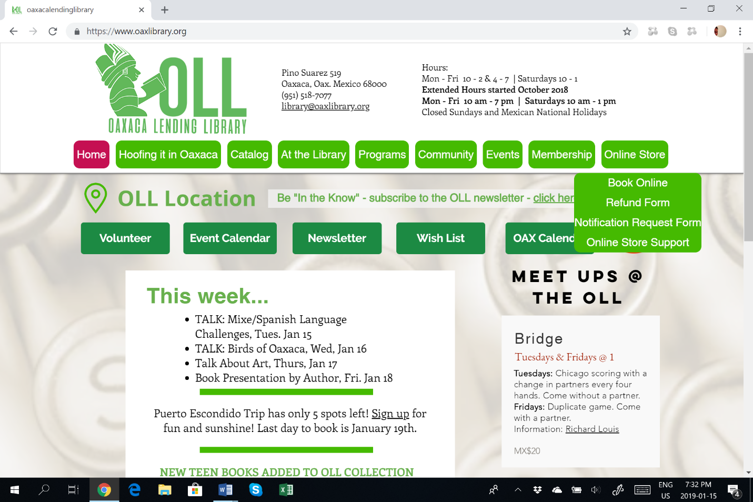

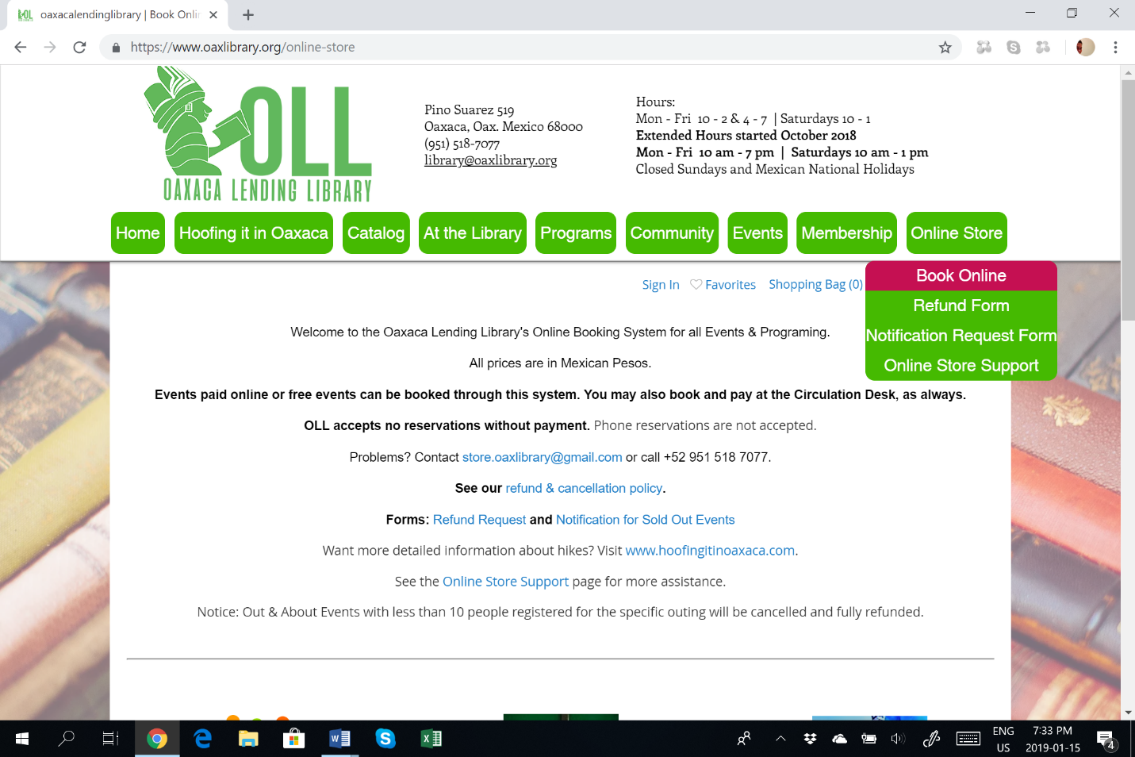
- Click: Sign In – circled above
Scroll UP if required – different screen sizes may open the below sign-in box halfway hidden on the screen.

- Click “Forgot Password”
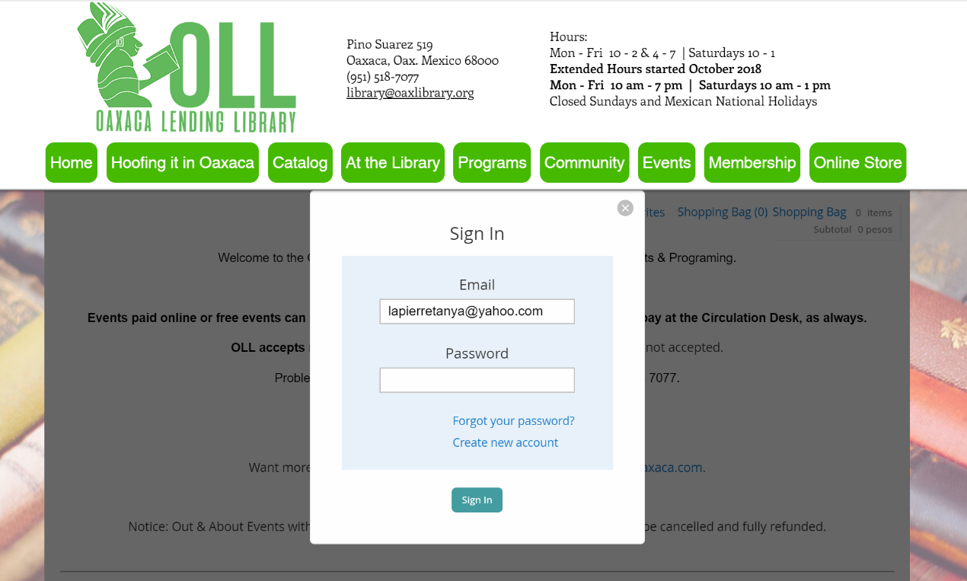
- Click “Reset password”

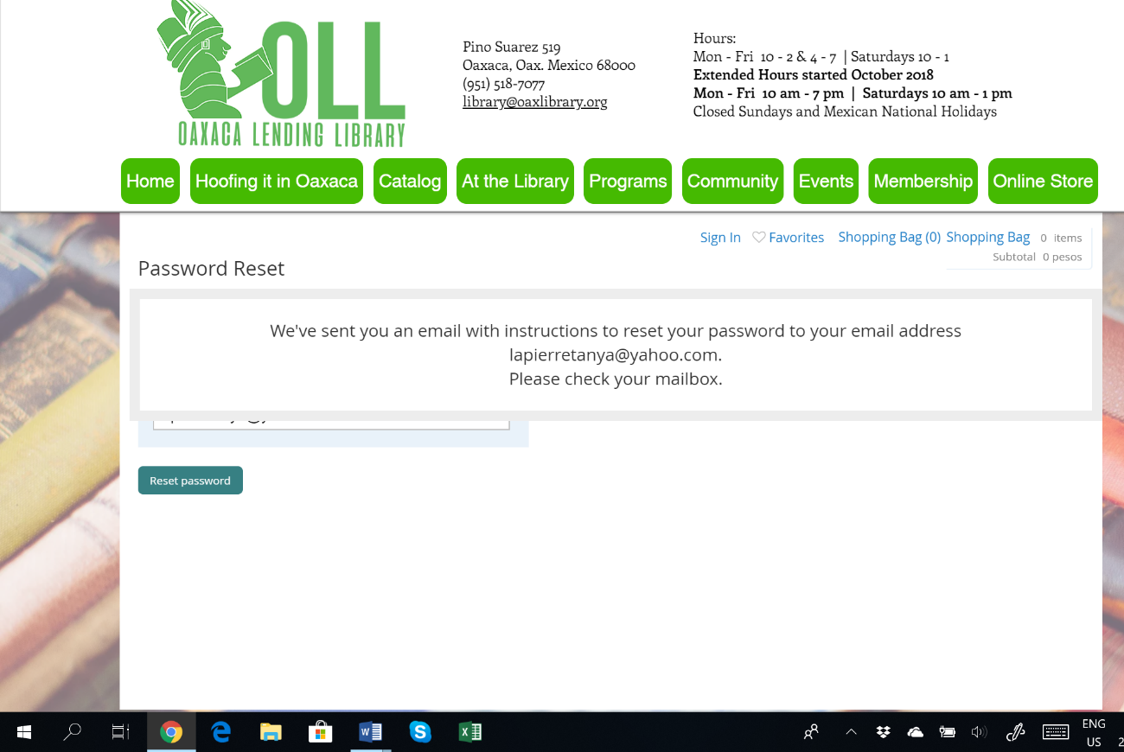

- The patron goes into their email account, and opens the email from the Online Store.
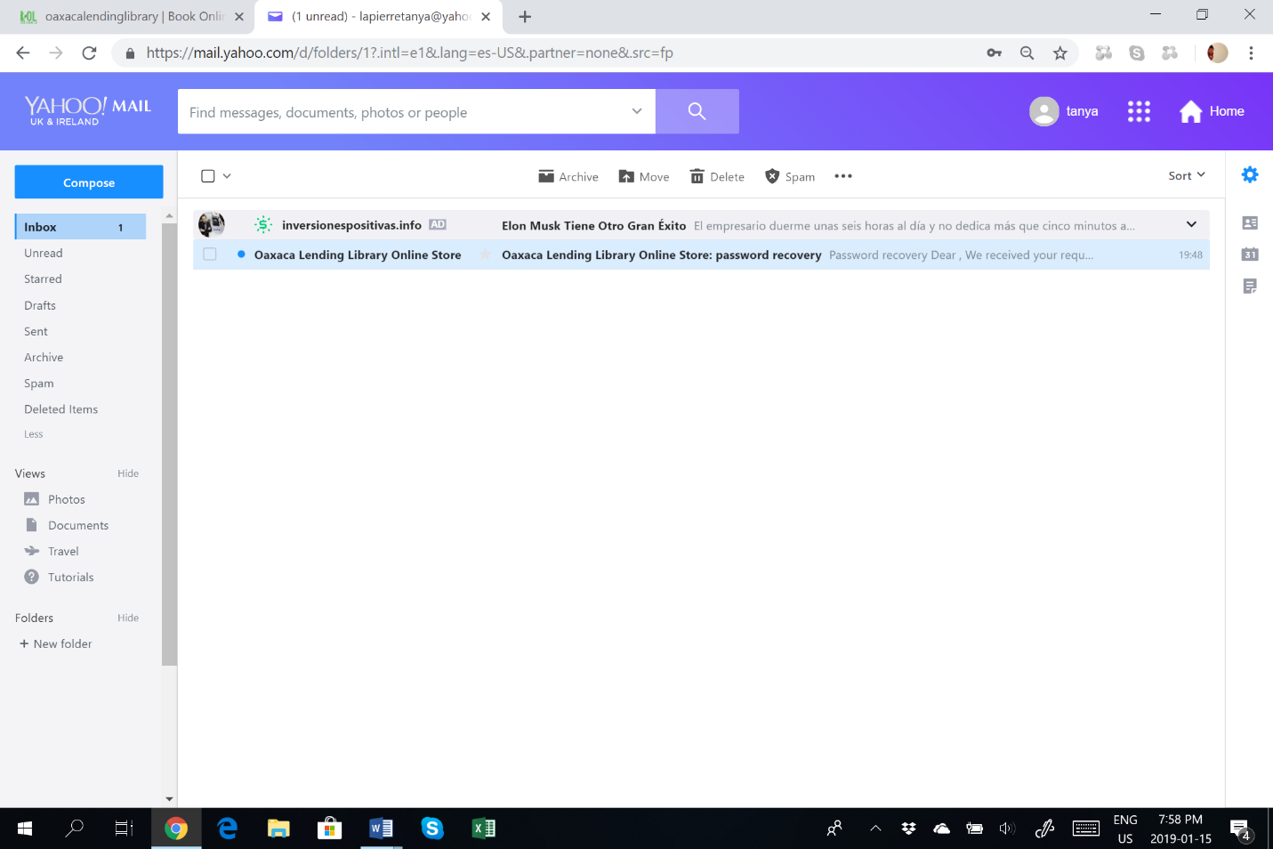

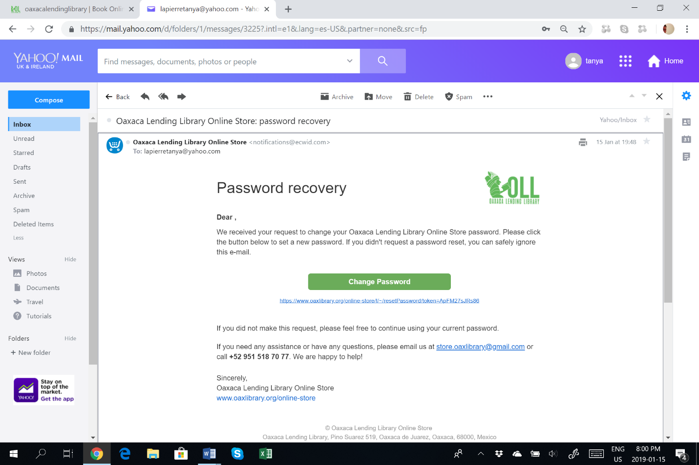

- They then click on the “Change Password” button. They are redirected to a new page on the OLL Store site and prompted to change their password.
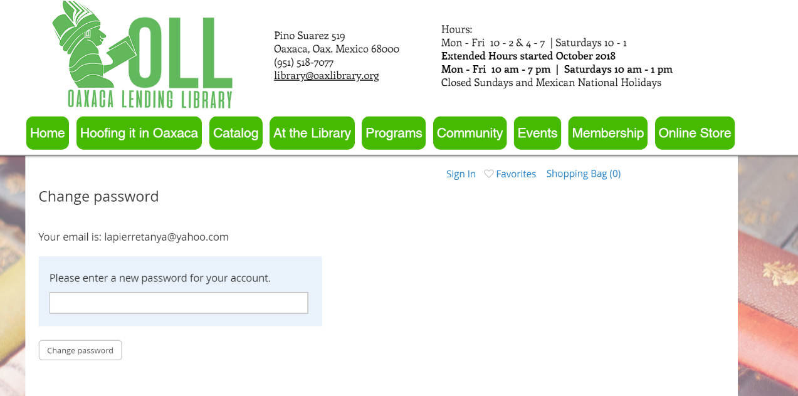

- They enter a new password (there are no restrictions - past passwords, or letters or number combinations, minimum or maximum number of characters …).
Once they enter a new password, they will be redirected to the online store, and they can then book or be booked into events.
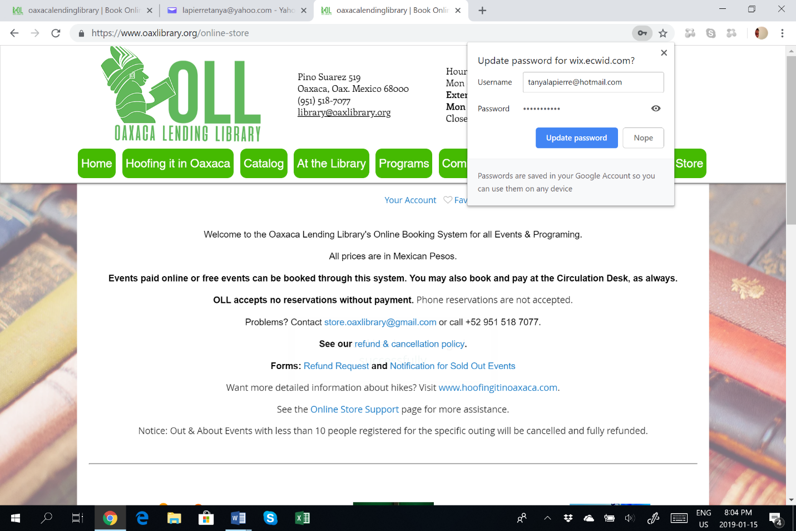
NOTE: Some browsers may ask if the patron wants the password to be remembered/updated. Say “NO” if using a public computer. If on a personal device, follow the practice of your choice.
Cards are available to write down the email address and password for the online store.

